**Design and implement a robust, distributed system using C++ that effectively leverages signals, sockets, and inter-process communication (IPC) to manage and coordinate multiple processes for a real-time data processing pipeline.**

**System Requirements**

**Data Ingestion: Continuously receive data from multiple sources (e.g., network sockets, files, sensors) and distribute it across multiple worker processes.**

**Data Processing: Distribute incoming data to multiple worker processes, each responsible for specific data transformations or calculations.**

**Error Handling: Implement robust error handling mechanisms using signals to gracefully handle unexpected events (e.g., process termination, network failures).**

**Inter-Process Communication: Utilize IPC (e.g., shared memory, message queues) for efficient communication and synchronization between processes.**

**Performance Optimization: Optimize the system for low latency and high throughput, considering factors like network congestion, process scheduling, and data transfer efficiency.**

**Scalability: Design the system to handle increasing data volumes and processing load by dynamically adjusting the number of worker processes.**

**Server:**

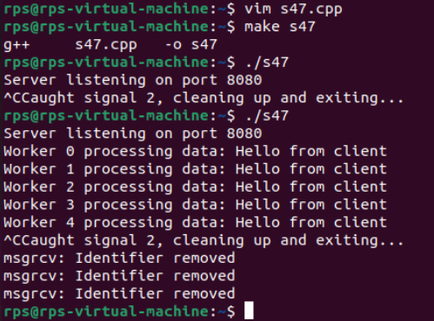

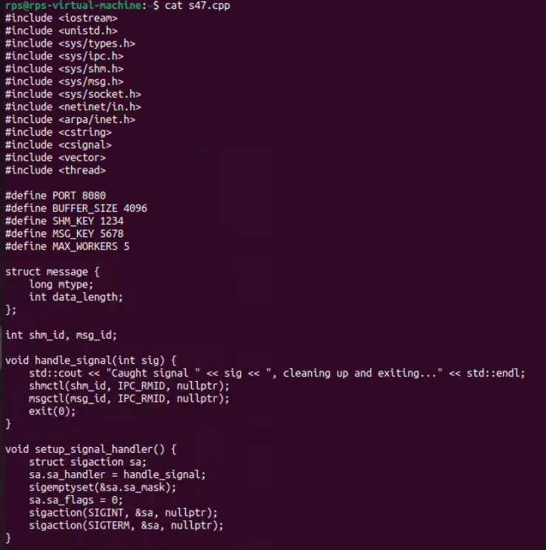

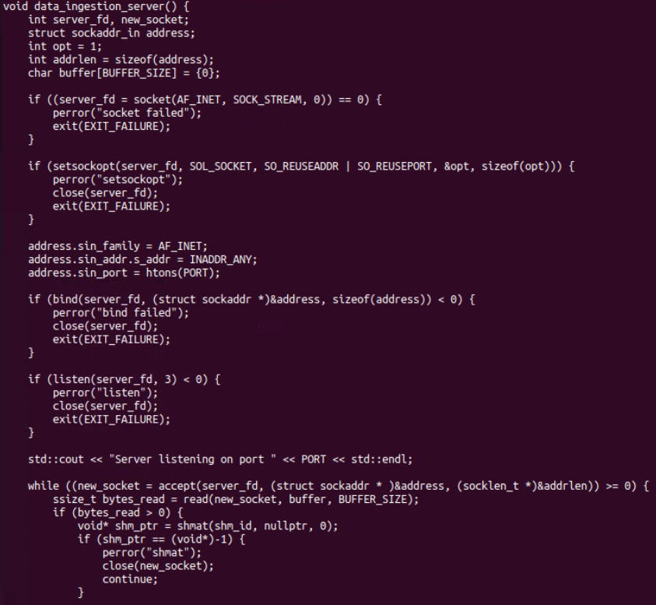

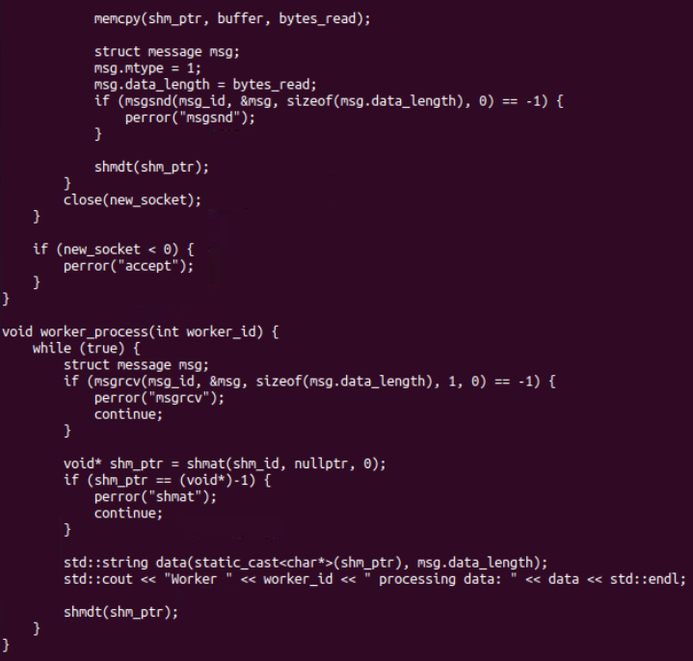

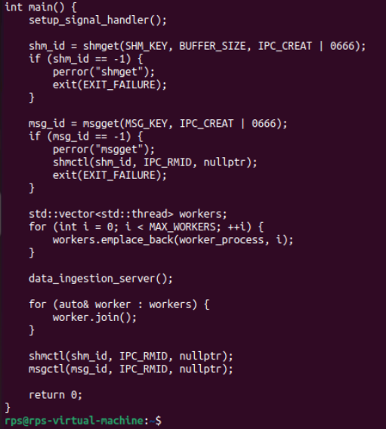

**Client:**

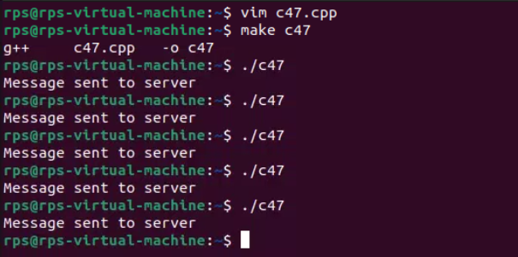

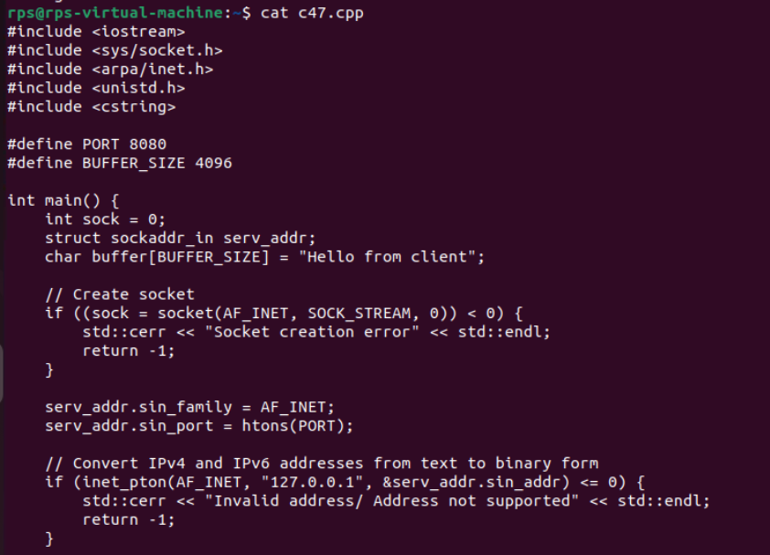

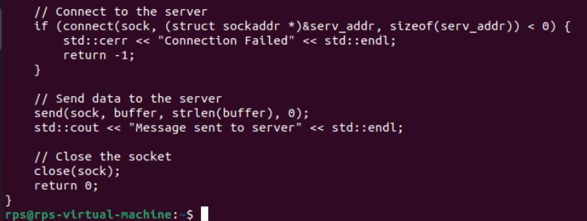

**Coding Questions in C++**

**Signal Handling:**

**Write a C++ program that sets up a signal handler for SIGINT. The program should perform some tasks and print a message when SIGINT is caught, then terminate gracefully.**

**How would you modify your program to handle multiple different signals, each with a unique handling function?**

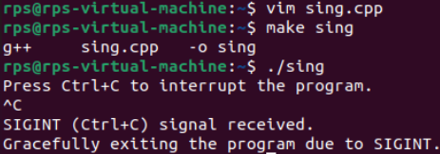

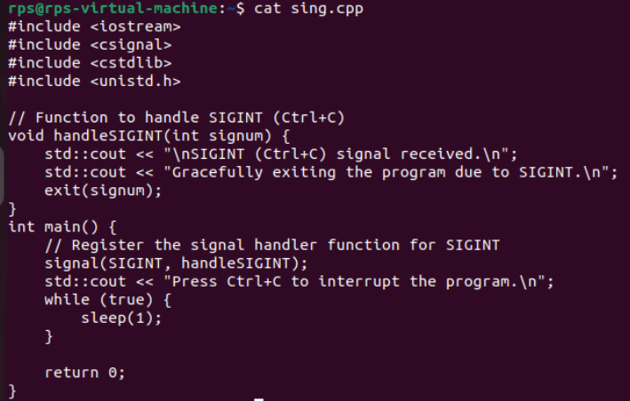

modify the program to handle SIGINT, SIGTERM, and SIGUSR1 signals:

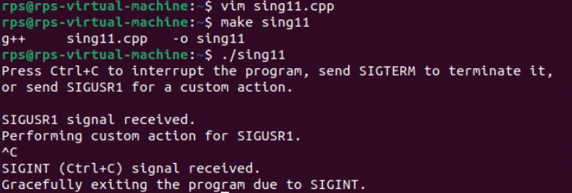

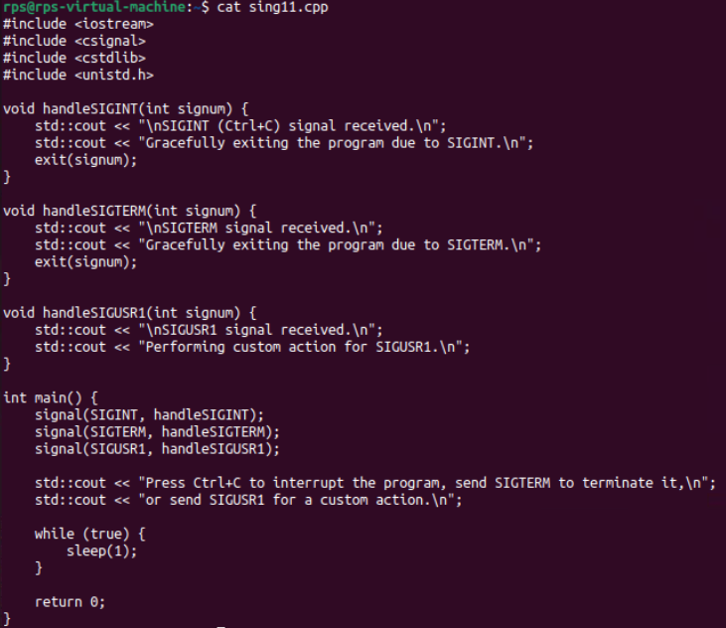

**Sockets for Network Communication:**

**Implement a simple echo server in C++ that listens on a specific port, accepts client connections, and echoes back any messages received from clients.**

**Write a client program that connects to the echo server, sends a message, and prints the echoed response.**

**Server:**

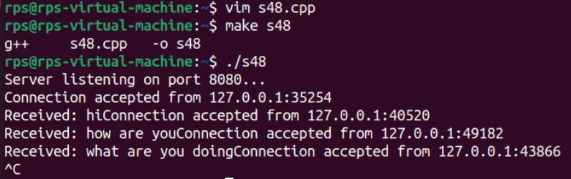

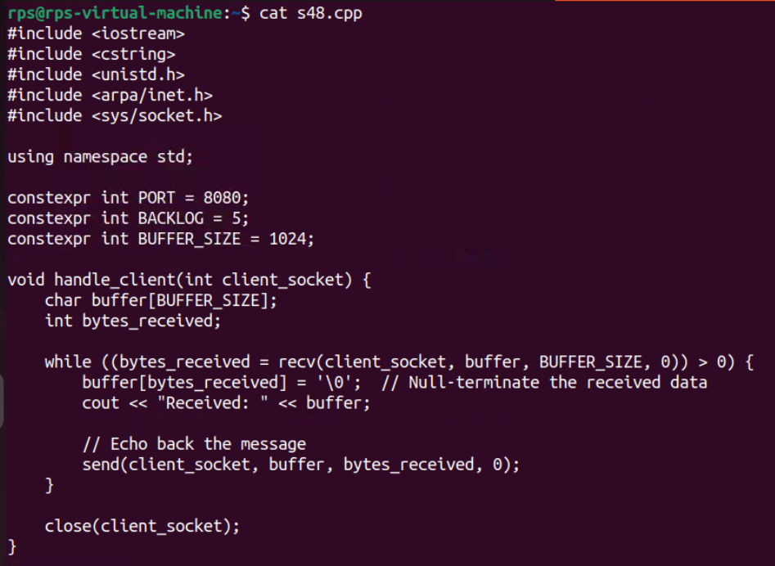

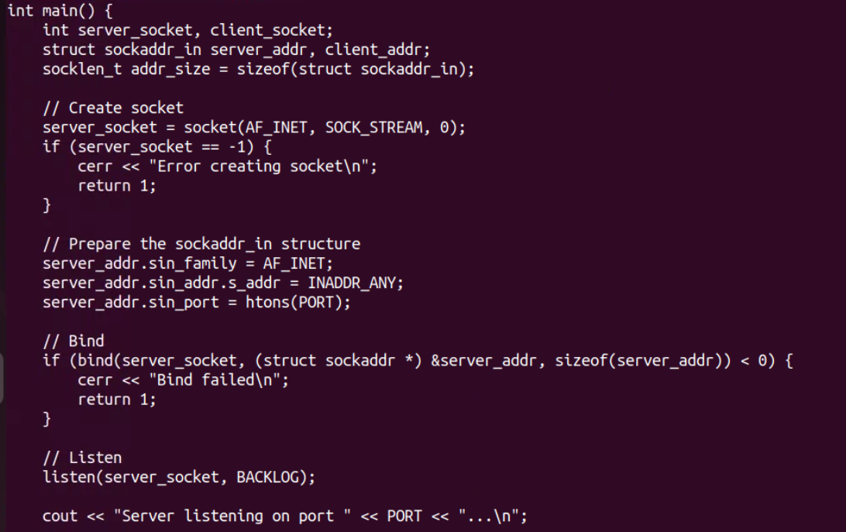

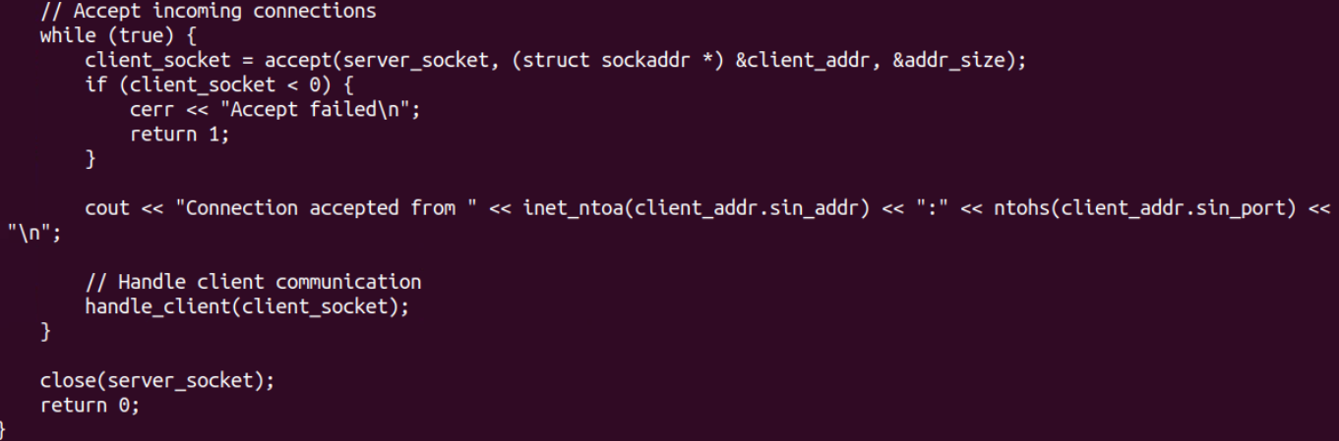

**Client:**

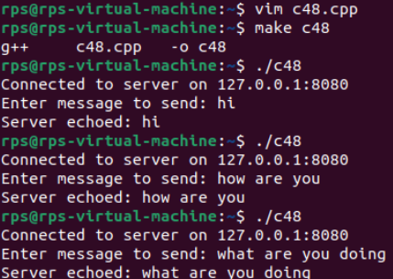

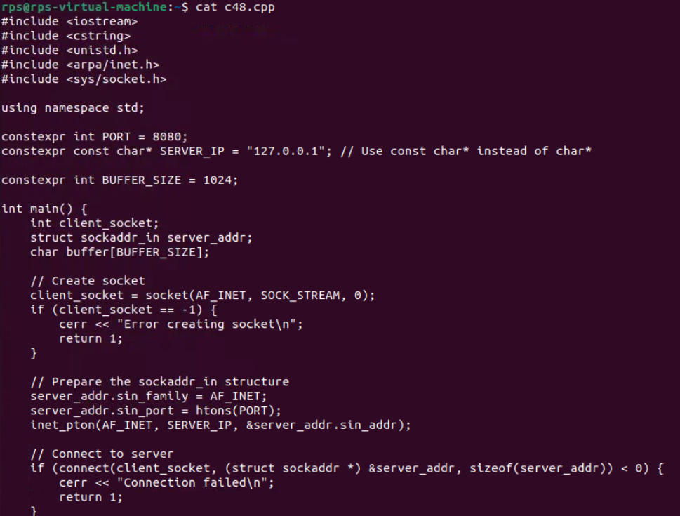

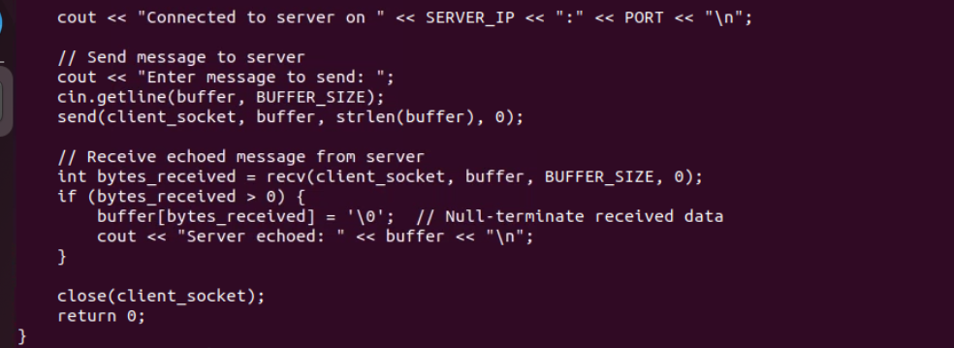

**Inter-Process Communication (IPC):**

**Write a C++ program that creates a parent process and a child process. Use a pipe for IPC to send a message from the parent to the child, and have the child process print the message.**

**How would you modify the program to use a message queue instead of a pipe for communication between the parent and child processes?**

Using a pipe the parent process will write a message to the pipe, and the child process will read and print the message.

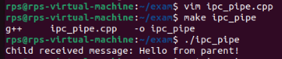

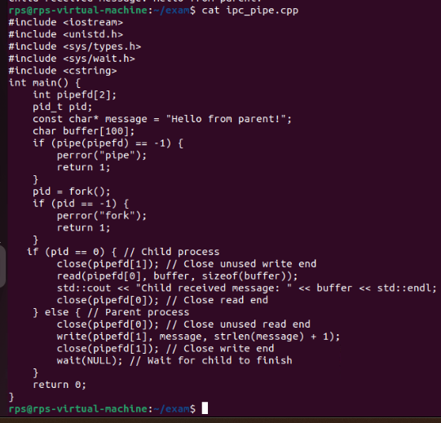

Modify to use a Message Queue

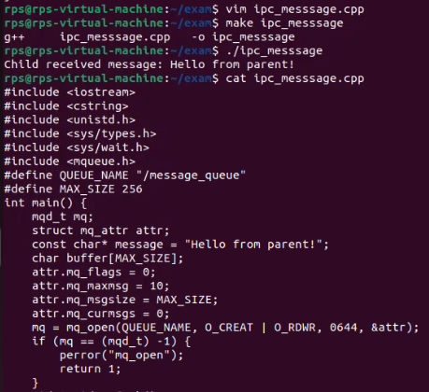

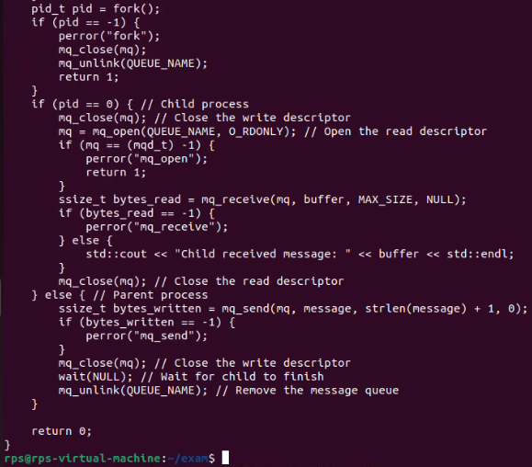

**Pipe:** Pipes are simpler and generally used for communication between related processes (like parent and child). They are unidirectional.

**Message Queue**: Message queues provide a more flexible IPC mechanism, allowing for message-based communication. They support asynchronous message passing and can be used between any processes that have the proper permissions.